**Practical No. 11**

**Aim: Configure IP routing using DNS (Domain Name System).**

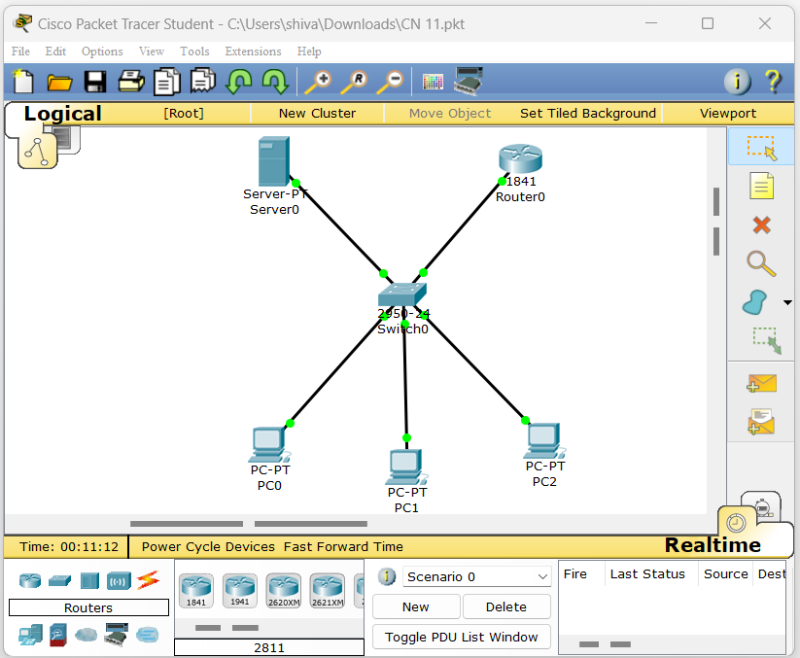

**Server 0.**

|  |  |
| --- | --- |
|  |  |

**Router 0. Pc 0.**

|  |  |
| --- | --- |
|  |  |

**Output:**

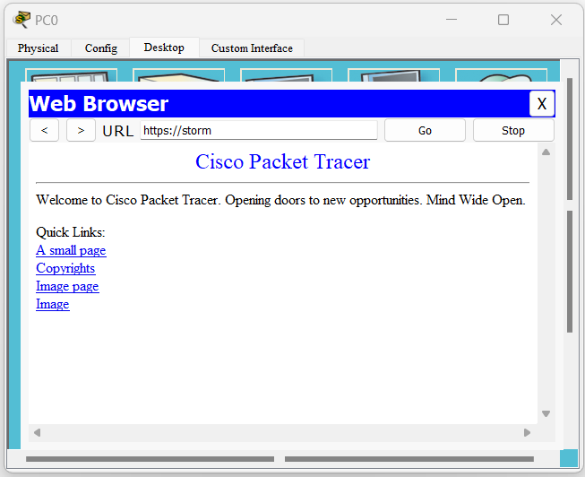

**Practical No. 12**

**Aim: Configure FTP (File Transfer Protocol) And HTTP (Hyper Text Transfer Protocol).**

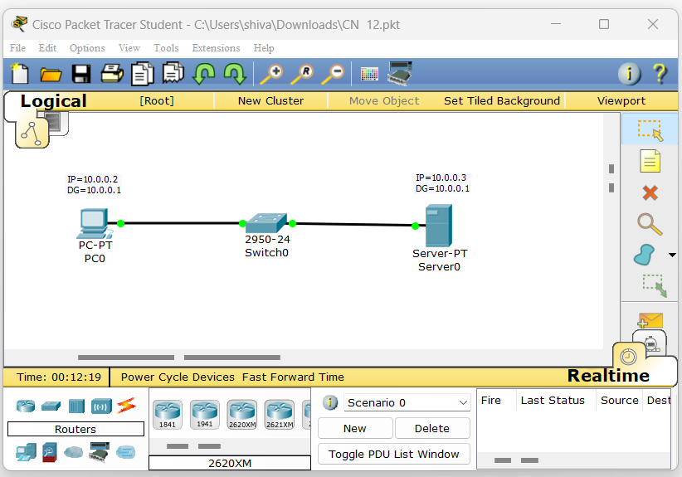

**Server 0. Pc 0.**

|  |  |
| --- | --- |
|  |  |

**Server 0.**

|  |  |
| --- | --- |
|  |  |

**Pc 0.**

|  |  |
| --- | --- |
|  |  |

**Server 0. Pc 0.**

|  |  |
| --- | --- |
|  |  |

**Practical No. 13**

**Aim: Configure TELNET (Teletype Network) And SSH (Secure Shell).**

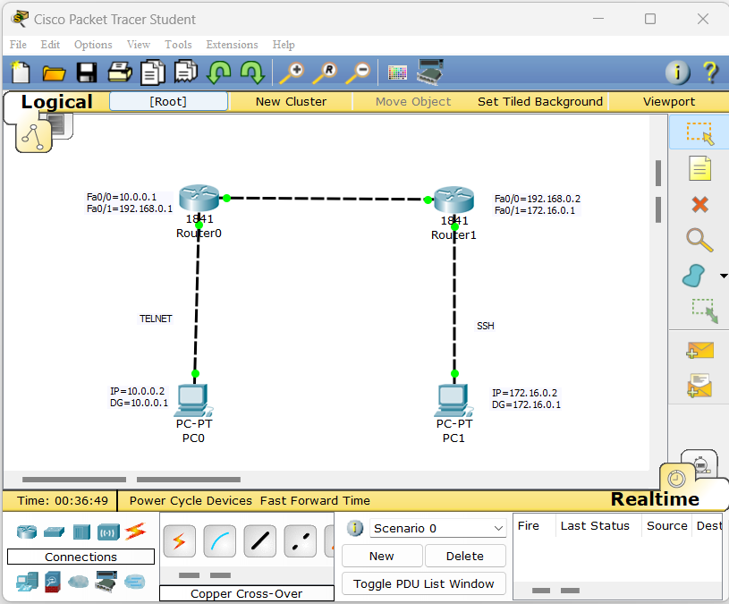

**Pc0. Pc1.**

|  |  |
| --- | --- |
|  |  |

**Router0.**

|  |  |
| --- | --- |
|  |  |

**Router1.**

|  |  |
| --- | --- |
|  |  |

**Router0.**

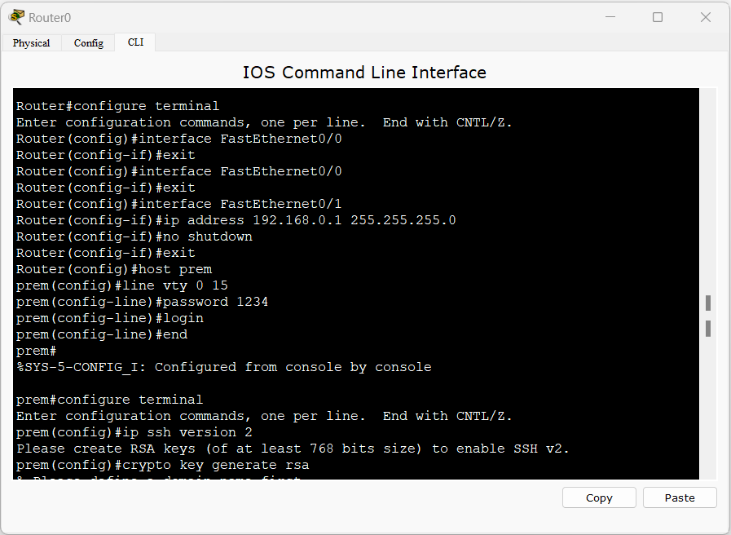

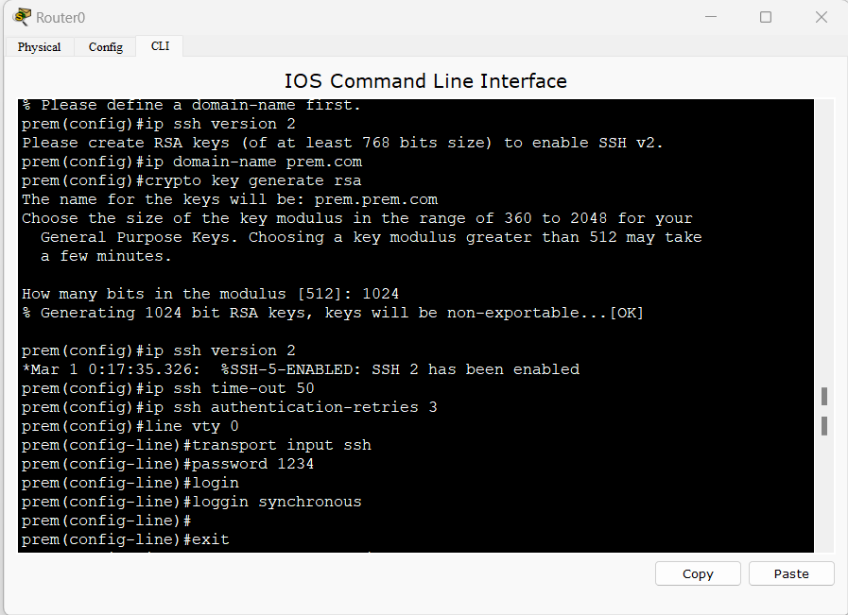

**Router1.**

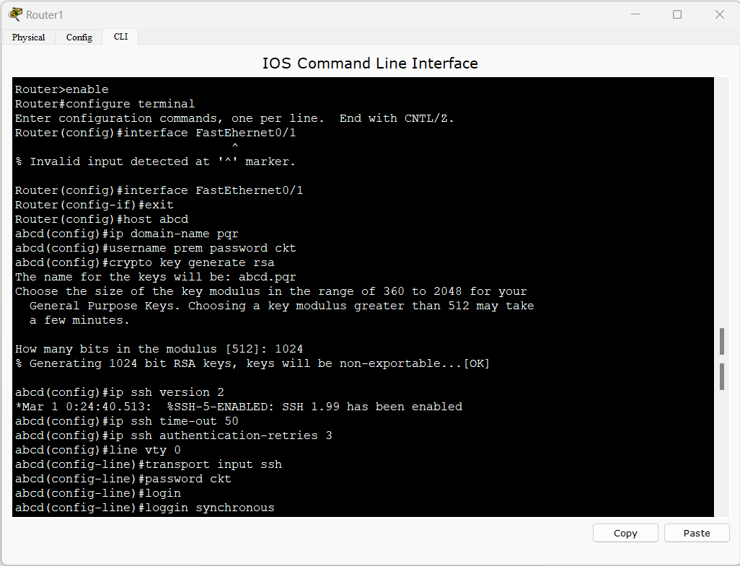

**Pc1.**

